WORKSHOP II

P1N

Submitted by Submitted to

Amanjot Singh Harsh Barot

Banking Web Application

First Impression

1. Concept is to build a web application for banking handling through online platform.
2. The market is open with few names like scotiabank.com, ICICI personal banking.
3. User get knowledge of all account information, personal banking, credit score.

Client Requirements

1. Login and signup of user.
2. Categories of banking account through online form.
3. User dashboard which provides account type and credit score.
4. Banking functionalities like
   1. Interac
   2. Transfer
   3. Withdrawal
   4. Cheque Book request.
   5. Demat account facilities.
5. The requirements of client for very elegant designs for all pages. In homepage there should be a wellness tips and list of all account categories. When user click on category the all account form will open.
6. In the homepage there should be a choosing section of form from where user can select their requirements and on submission the selected field page will open.

Required Pages

1. There should be 8-10 pages first is homepage, about page, services page.
2. Contact Page
3. Dashboard Account
4. Advisors page
5. Policies Page
6. Terms & Conditions
7. Insight and advice blogs
8. Payment Page.
9. Interac Services
10. Request Page

Project Scope

1. The idea is quite simple and there are few competitors in this field.
2. The client has content material photos, videos and content.
3. Client does have promotional material from where developer can do seo and smm.
4. Client deadline is to complete this project in 2 months with whole development.

Main Goal

1. To successfully develop a dynamic responsive website application that enables users to get all account categories of various price ranges.
2. The main goal is to provide a website which provide functionality of advisors where user can advices for the demat account according to various policies.

SERVICE OFFERED

Services which are provided for one web project integrations are design, development, data storage, server management, search engine optimization.Once we go through with client requirements then the production script will be planned and shared to client. After get approval from client then implementation of project will be started.

PHASES :

**Design :** First of all according to client requirements graphic designing of mockups will be implemented for the web app project. Service will be offered in adobe Photoshop, Illustrator, sketch.

1. **LOGO CREATION :**  After getting the product information the relevant logo will be designed. There will be multiple logos in different color contrasts and provided to client for chosing one.
2. **Homepage Design :** Homepage design will have header menus, logo and some contact information. Afterwards banners in the form of carousals with some texts. In the second section there should be widgets of services,Testimonials and footer with four columns.
3. **Page Designs :** Then, multiple pages will be implemented like services, about us, blogs, contact us. All the pages will have same header & footer.
4. **PSD TO HTML CONVERSION :** Then psd approved by client will be converted in to html and css with some animation effects with the help of Javascript, JQuery.
5. **Responsiveness of Designs :** All the pages will be mobile supported and with the help of media queries the web pages will be fitted into all mobile resolutions.

**DEVELOPMENT :**

**BACKEND DEVELOPMENT:**  Backend development will be integrated with the help of backend languages like PHP, node, Java.

**DATABASE :** Afterwards data storage will be done by database administrator in SQL, Mysqli, Oracle, Mongo DB.

**Server Migration :**

**Server Migration :** Afterwards whole web app will move to client’s server like hosting on linux based server with integrated domain.

Servers like : AWS, Godaddy, Cpannel, 000Webhosting

**Final Testing:**

In final testing all functionalities, designs, responsive, animation will be tested and then web app is live to use for clients.

**Flow Chart**

START

DESIGN

DEVELOPMENT

DB INTEGRATION

SERVER MIGRATION

FINAL TESTING

SEO

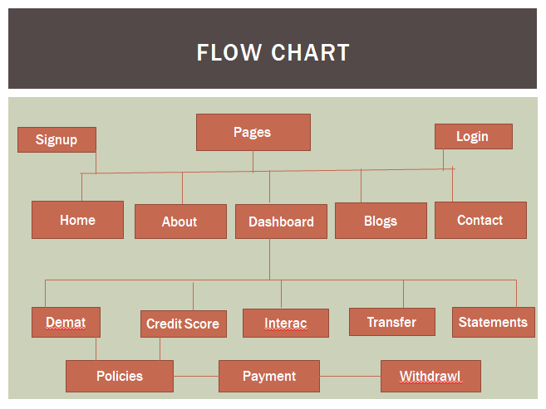

**Production and Planning**

1. Visual design and research
2. Client approval and proposal
3. Alpha version on company’s server
4. Client presentation and approval
5. BETA version on clients server
6. Testing and correction
7. Finalize SEO

|  |  |  |  |  |
| --- | --- | --- | --- | --- |
| Production Script / HOURS | 150 Hours | 150 HOURS | 30 Hours | 40 Hours |
| Design | Logo |  |  |  |
|  | PSD |  |  |  |
|  | PSD to HTML |  |  |  |
|  | Animation |  |  |  |
|  | Responsiveness |  |  |  |
| DEVELOPMENT |  | Backend Implementation |  |  |
|  |  | Database Integration |  |  |
| SERVER MIGRATION |  |  | Migration to clients server |  |
| Final Testing |  |  |  | Final testing of all functionalities and animation |

Quotations :

* Planning and client meeting : 1000$
* Alpha Version : 1500$
* Beta Version : 2000$
* Deployment : 3000$
* Maintenance : 4000$
* Total : 11500$